Assignment – 4 Python Basics

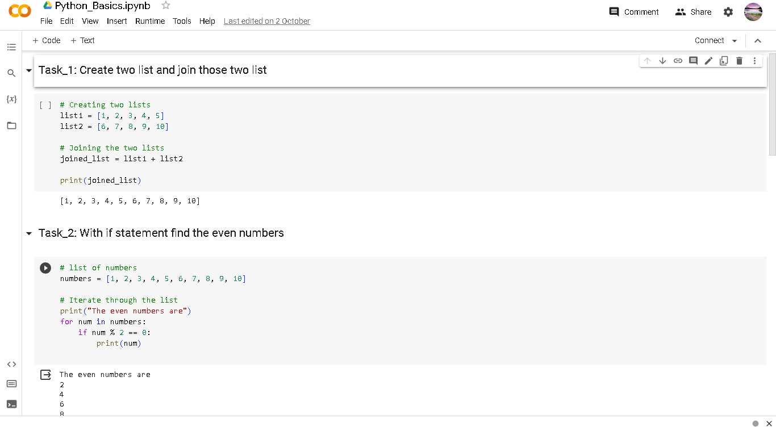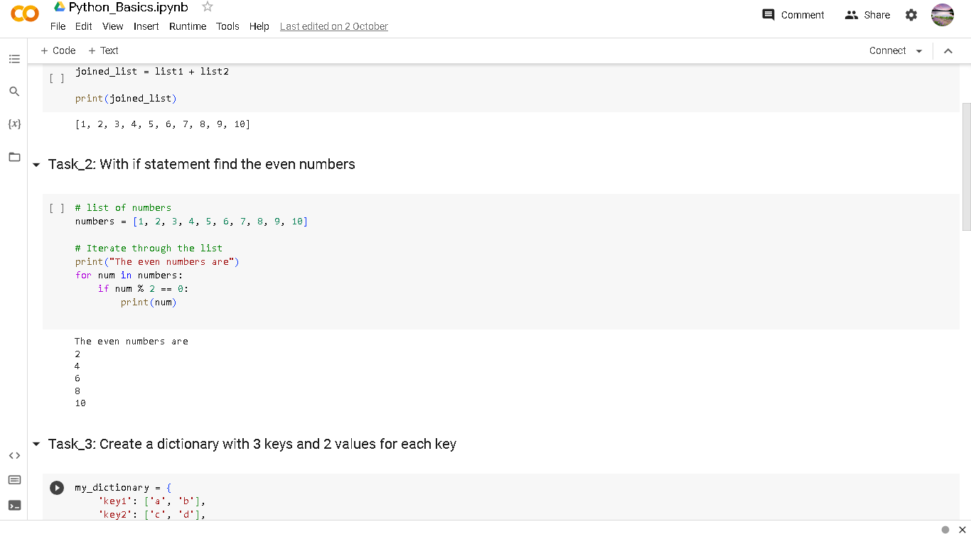Name: Sathiya Rubha M

NM Id: au611220104134

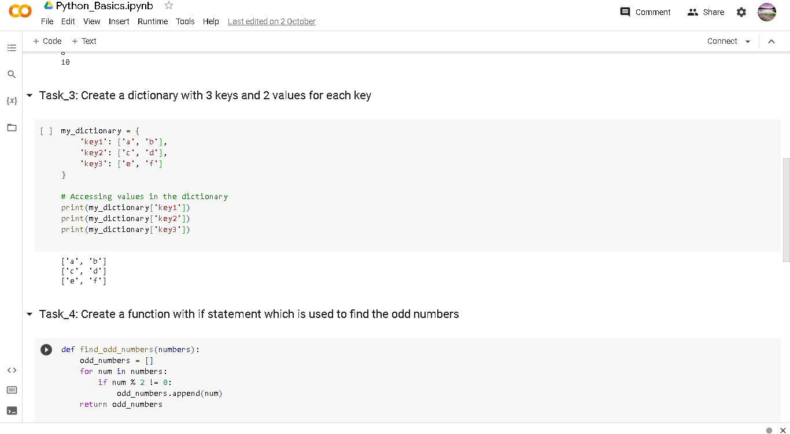

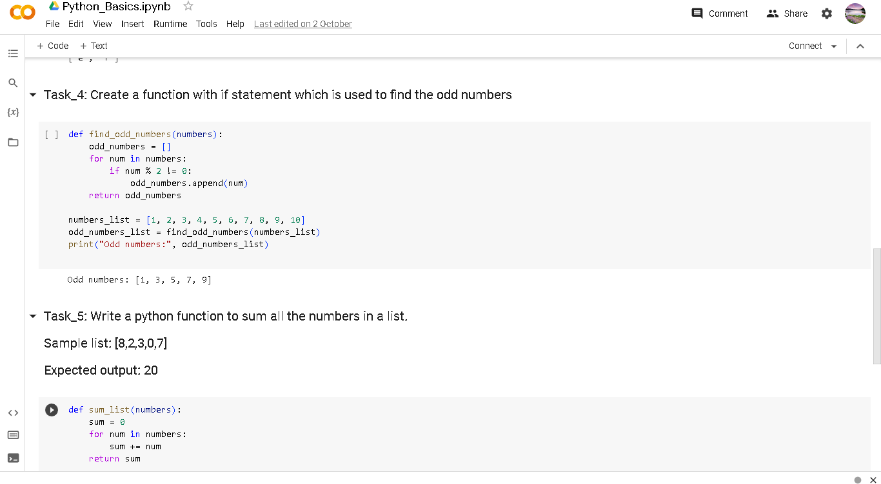

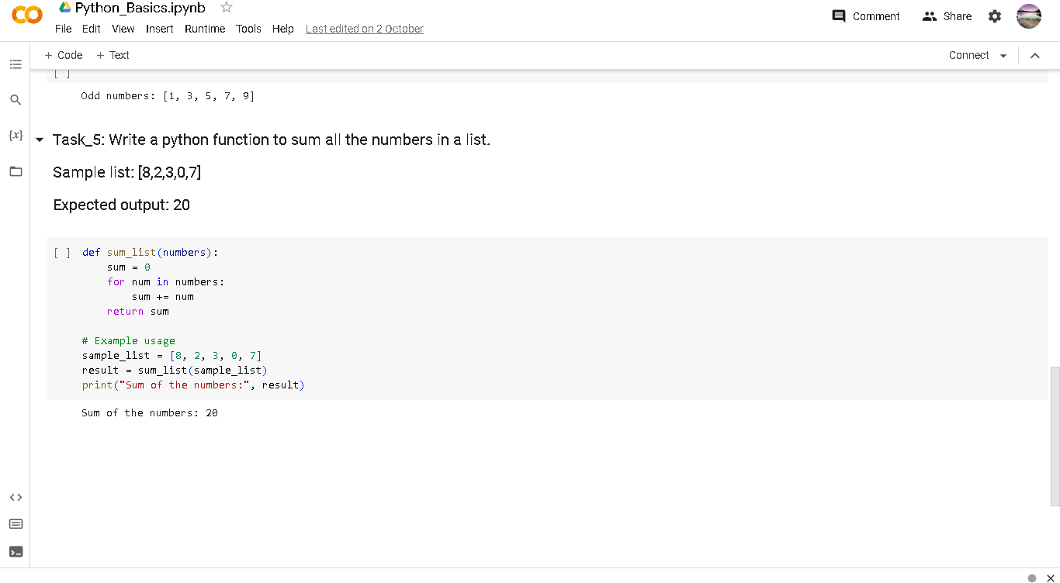

Python file link:

https://colab.research.google.com/drive/1VA73_yIN_gASZh7IGR6Gnehux4iu31Xa

?usp=sharing